***Nairobi National Park Tour***

Your adventure begins early in the morning with a prompt pick-up from your hotel or residence in Nairobi at 6:00 am. From here, you’ll be driven to the iconic Nairobi National Park, where the city meets the wild. As the sun rises, you’ll embark on an exclusive game drive in a private luxury safari vehicle. This is the best time to spot wildlife, such as lions, rhinos, giraffes, buffalo, and countless bird species while they roam the open savannah against the dramatic backdrop of Nairobi’s skyline.

National Park is a unique ecosystem by being the only protected area in the world close to a capital city, located just 7kms from Nairobi’s city centre. Nairobi National Park is a perfect place for a half-day or full day excursion-one of the only places on earth where you can be on safari with skyscrapers as part of your backdrop. It’s an ideal layover escape or add-on to your existing safari.

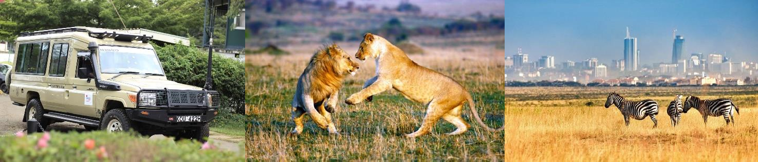

**COST**

* 1 pax at $ 250
* 2 pax at $ 160 per person
* 4 pax at $105 per person
* 6 pax at $ 90 per person

Above rate include;

* Pick up and drop off at your hotel/residence in Nairobi
* Transport in a 4x4 safari Land Cruiser with a photographic roof hatch for easy game viewing and photography.
* Park entry fees
* 4 hours game viewing within Nairobi National Park
* A bottle of mineralized drinking water (please carry a reusable water bottle)

What to carry;

* Passport
* Tips and gratuities for your driver guide.